1.SignUp Page:

2.Login Page:

3.AdminDashboard:

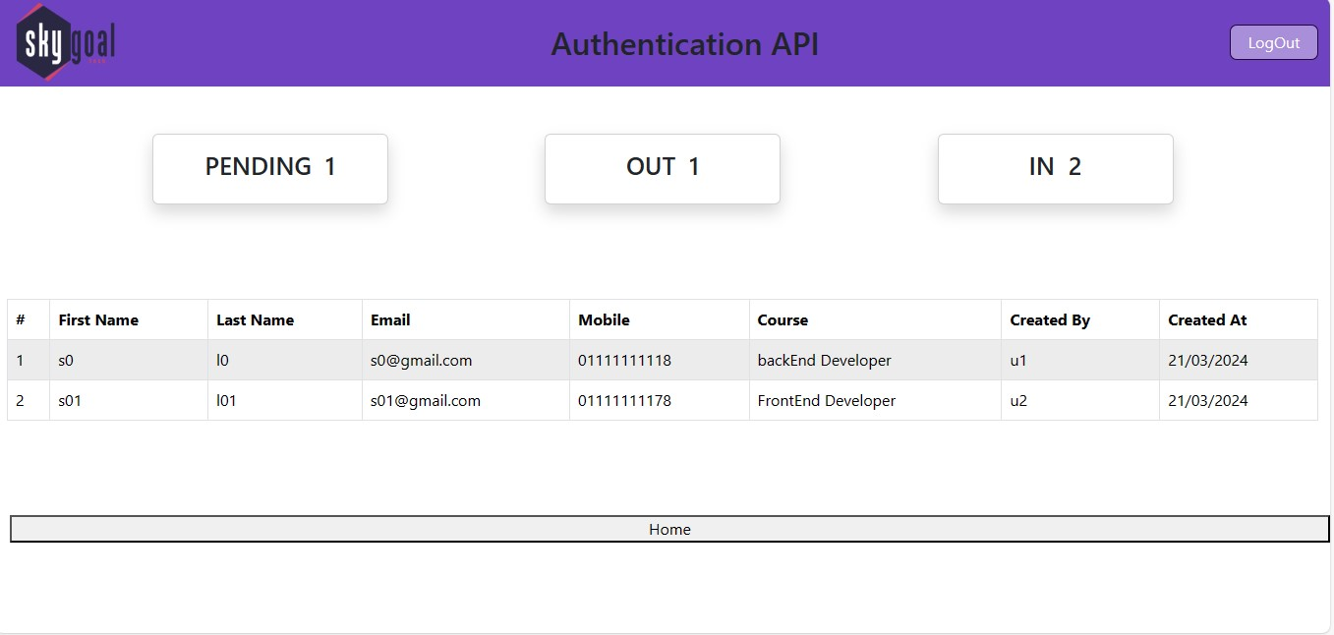

4.HomePage:

4.Student Crud:

5.Course Registration Form:

